



Presents the 2009 Tourism
And Entertainment Legacy Award to
International Goodwill Ambassador
Honorable Oscar J. Webb, Jr
Who
Celebrates His
40th year of
Entrepreneurship and Humanitarian work
Worldwide
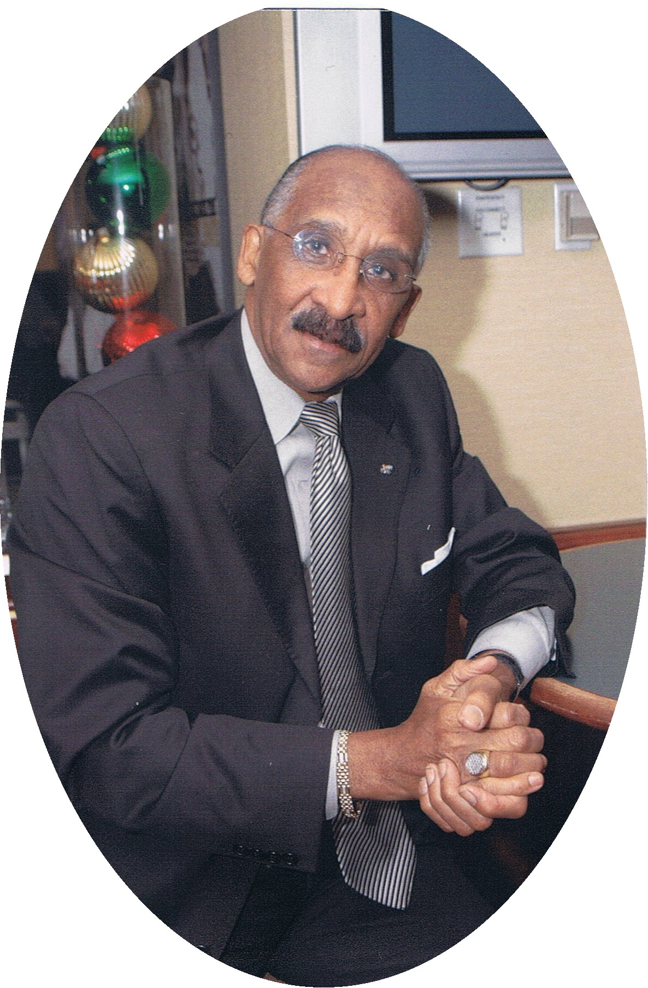

Sandton Sun & Towers Inter Continental
Johannesburg, South Africa
February 10, 2009
Carl Neil 083 918 8334

